
GOURAB SEN
C/o Sharada Nilaya, House No.33, 3rd Cross 6th Main, Mathikere, Bangalore:560054
gauravatjob@hotmail.com
8981691378 / 9071250001

JOB OBJECTIVE
Seeking a position as a DBA in initiatives that utilize state-of-the-art, software with a creative, technology-driven organization in an environment that encourages innovative thinking, recognition and career development.
ITIL Certified Oracle DBA as well as SQL/PLQL Developer, willing to work in challenging environment.
PROFILE SUMMARY

- Currently supporting for one of the world's largest Automation Solutions, Commercial & Residential Solutions company for its 6 production databases
- Engaged in DB Designing, creating Tables, Indexes, Primary-Foreign Key Relationships, Views, MV's, Functions, Triggers, Exceptions in PostgreSQL 10.4 Version.
- Supported in one of US's more than 100 years old bank for its 50 databases.
- Supported for more than 300 instances for more than 50 Customers for Data Intensity
- Engaged in doing POC's on Dockers and Kubernetes
- Assisted in SLK's BI Project.
- Work as SOP by adhering strictly following SLA
- Creating, Maintaining stand by databases, troubleshooting Dataguard issues
- Hands on Experience on RAC and Troubleshooting of the issues
- Maintenance of production database and development database which includes tablespace space management, user creation, privileges, roles etc.
- Automated hot backups using a combination of incremental, differential and full RMAN backups.
- Maintaining archive data on appropriate storage devices.
- Tracing, troubleshooting with database performance using Tools Like ADDM, AWR, ASH and tuning issues.
- Export/Import of oracle databases.
- Database Refreshes/Cloning.
- Analyzing and validating database objects.
- On call support 24x7.

TECHNICAL SKILLS

- Operating System: Window 2008, 2012, Solaris, Red Hat Linux 5.0, 5.4, HP-UX
- RDBMS: Oracle 8i, 9iR2, 10gR1 & R2, 11gR1 & R2, 12C
- Tuning Tool: AWR, ADDM, ASH
- Backup: Cold, Hot backup, RMAN, Import/Export
- Tools: SQL Plus, Oracle Enterprise Manager (OEM),
- Script: Basic:UNIX/Linux shell script
- Language: SQL, PL/SQL

WORK PROFILE

- Company Name: SLK Softwares Pvt Ltd.
- Designation: DBA
- Duration: Since Oct'2014 to till date

ABOUT SELF

- Abilities in handling multiple priorities with a genuine interest in personal & professional development
- Quick learner & highly energetic with a keen aptitude for learning and applying new knowledge resourcefully
- Team player with strong communication, analytical, problem solving and organizational skills
- Focused & goal driven with strong work ethics, continuously striving for improvement coupled with commitment to offer quality best results.

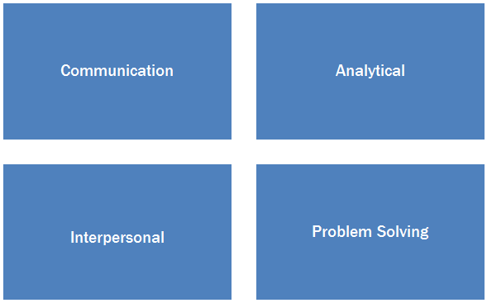
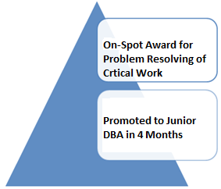

ORGANIZATIONAL TRAININGS / ACADEMIC PROJECTS
- Axelos ITIL Foundation Certificate
- Attended Oracle 12C Foundation Course
- Comprehensive knowledge base & notable soft skills nurtured during academic projects / training (from IBMACE) like namely ‘Call Centre Management of Futuristic System using Oracle 9i’ & ‘Java Projects’ in College.

OTHER ACCOLADE
- Received SPOT Award for fixing a Critical Work
- Secured ^{2nd} position in Quiz Competition organised by WBREDA in 2009

EDUCATION
2013 B.Tech. (C.S.E) from Birbhum Institute of Engineering & Technology, SURI, WB affiliated to W.B.U.T. with CGPA 7.19
2005 12th from Central Academy, Gorakhpur affiliated to C.B.S.E. Board
2003 10th from Holy Mission High School, Samastipur affiliated to C.B.S.E. Board

PERSONAL DETAILS
Date of Birth : 26th July, 1988
Languages Known : English, Bengali, Telugu and Hindi
Permanent Address : Near Shahganj P.O., P.O.-Shahganj, District: Hooghly-712104, West Bengal

